Front End Engineering-II

Project Report Semester-IV (Batch-2022)

**Image Gallery**



**Supervised By: Submitted By:**

Dr. Raveesh Samkaria Saksham Bharti,

2210990762 (G-12)

**Department of Computer Science and Engineering Chit-**

# Abstract

The image gallery is a web-based tool designed to help users organize and showcase their images effectively. It provides a user-friendly interface for uploading images and creating galleries, with features for customization and display options.

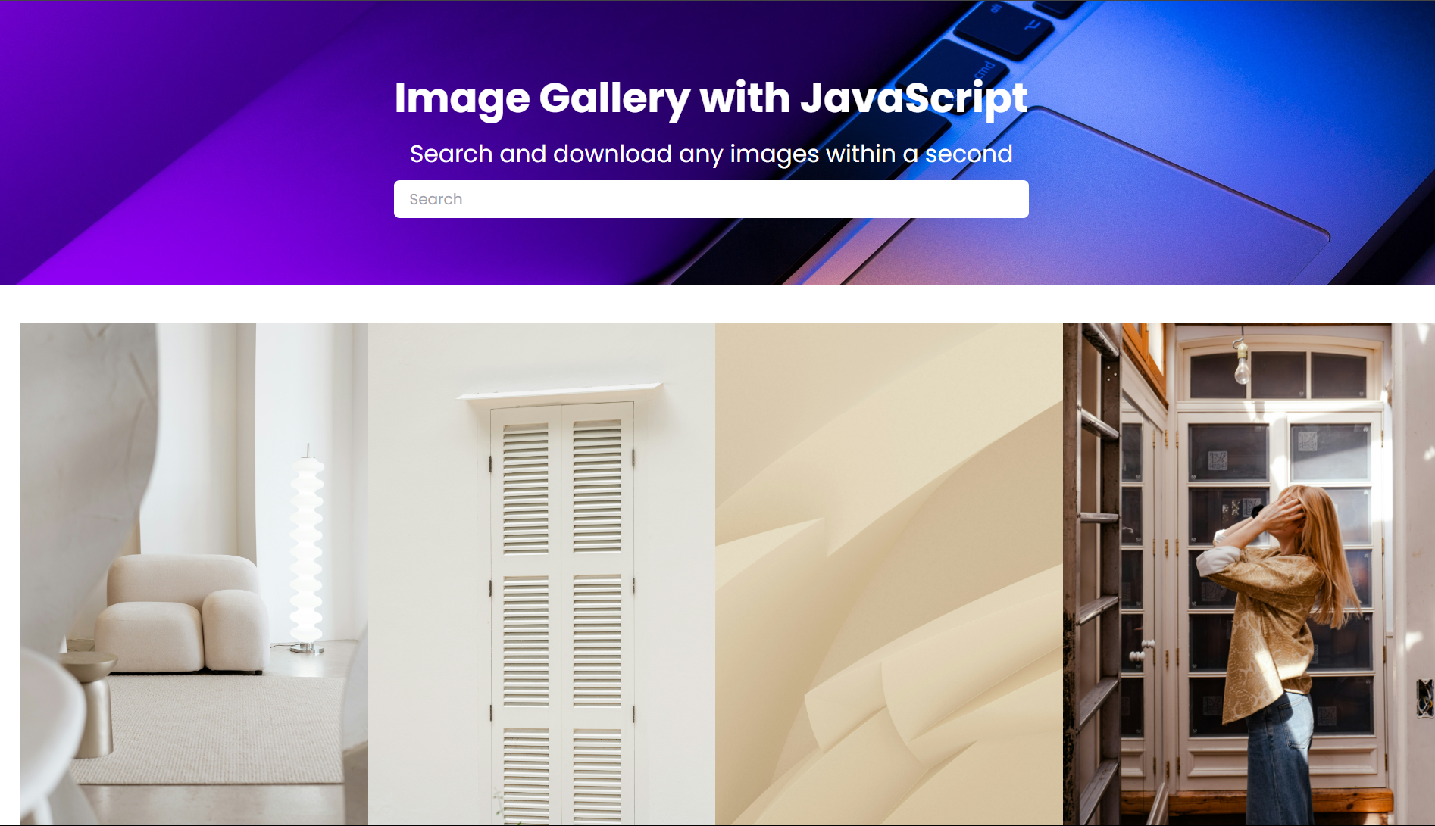

# INDEX

|  |  |  |
| --- | --- | --- |
| **S.No.** | **Title** | **Page Number(s)** |
| 1 | Introduction | 4 |
| 2 | Problem Statement | 5 |
| 3 | Software Requirements | 5 |
| 4 | Proposed Design | 6-13 |
| 5 | Results | 14-17 |
| 6 | References | 18 |

**1. Introduction**The Image Gallery web application offers a versatile platform for organizing and presenting images online. In an era increasingly focused on visual content and digital storytelling, such tools serve as invaluable resources for individuals and businesses alike. This introduction outlines the background, objectives, and significance of the Image Gallery application.

* 1. **Background:**As technology advances, the demand for efficient and user-friendly tools becomes more evident. The Image Gallery meets a fundamental need: the ability to organize and showcase images seamlessly without the hassle of manual sorting or complex software. In today's digital landscape, where visual content reigns supreme, users expect intuitive experiences that deliver results swiftly and effectively.

**1.2 Objectives:**The core aim of the Image Gallery is to offer a user-friendly platform for individuals to upload their images and create visually appealing galleries effortlessly. This application seeks to streamline the process of organizing and presenting images, eliminating the need for users to resort to manual sorting or complex software. Furthermore, the Image Gallery prioritizes accuracy in image display, ensuring that images are showcased reliably and aesthetically across various devices and browsers.

**1.3 Significance:S**ignificance of the Image Gallery lies in its capacity to simplify the management and presentation of images, which are integral to various personal, academic, and professional endeavors. Whether for personal portfolios, educational presentations, or business marketing materials, the ability to organize and showcase images effectively is paramount. By providing a user-friendly platform for these tasks, the Image Gallery enhances efficiency and creativity, ultimately saving users valuable time and effort.

**Problem Statement** Existing image gallery tools sometimes fall short in providing a seamless and intuitive experience, leading to frustration for users. Many platforms lack essential features and customization options, resulting in subpar image organization and presentation. There's an increasing demand for a precise, user-friendly, and versatile image gallery solution that ensures seamless image management while considering diverse user preferences and requirements. Such a tool should cater to users across various platforms and devices, offering a reliable and enjoyable experience for organizing and showcasing images effectively.

**1. Software Requirements a) Integrated Development Environment (IDE):** Visual Studio Code (VS Code) for code editing and project management.**b) Frontend Technologies: HTML:** Markup language for structuring the image gallery interface. **CSS:** Styling language for enhancing the presentation and layout of the image gallery. **JavaScript (JS):** Programming language for implementing interactive features andimage gallery logic.**c) User Interface (UI) Framework: Tailwind CSS:** Frontend utility-first CSS framework for building responsive and visually appealing user interfaces for the image gallery**.**

**d) Version Control: Git:** Distributed version control system for tracking changes in the image gallery codebase. **2. Proposed Design**

**User Interface Design**: Utilize Tailwind for a responsive and visually appealing layout. Employ intuitive organization for easy navigation and use.

**Frontend Development:** Develop using HTML, CSS, and JavaScript. Utilize HTML5 semantics, CSS for styling, and JavaScript for dynamic updates and image gallery logic.

**User Experience Optimization:** Focus on real-time feedback, interactive elements, and cross-browser compatibility for seamless user experience across devices.

**Testing and Quality Assurance:** Conduct thorough testing, including manual and unit tests, to ensure the functionality and reliability of the calculator. Maintain consistency in the user interface and behavior.

**Documentation and Deployment:** Provide detailed documentation for users and developers. Deploy the calculator on a web server with a domain for accessibility. Regularly update and maintain documentation.

**Integration of Libraries:** Utilize libraries like SweetAlert2 for user-friendly alerts and additional enhancements for improved user engagement and experience.

## File Structure

Ensuring proper file and folder structure to maintain consistent file paths and clean structure.

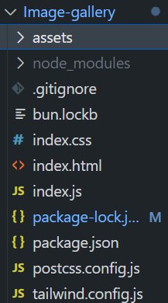

## HTML Code Structure

These screenshots present the HTML code for our Image Gallery project, revealing the layout and content of our web pages in a code format.

<!DOCTYPE html>

<html lang="en">

<head>

    <meta charset="UTF-8">

    <meta name="viewport" content="width=device-width, initial-scale=1.0">

    <title>Image Gallery</title>

    <link rel="stylesheet" href="index.css">

</head>

<body class="overflow-x-hidden">

    <div class="w-screen p-0 m-0 font-poppins ">

        <div class=" mybg h-[300px] flex flex-col items-center justify-center">

            <div class="w-fit mx-auto flex flex-col justify-center items-center ">

                <h1 class=" font-bold text-[2.7rem] text-white">Image Gallery with JavaScript</h1>

                <p class="font-normal py-[8px] text-[1.57rem] text-white">Search and download any images within a second

                </p>

                <input type="text" name="" placeholder="Search" id=""

                    class=" w-full px-4 py-2 rounded-md focus:outline-none">

            </div>

        </div>

        <div class=" columns-4 flex-wrap mt-[40px] w-[95%] gap-2 mx-auto" id="imgcont">

            <!-- <div id="loading" class=" text-red-400">Loading....</div>   -->

            <!-- <div class="w-[394px] flex flex-col mb-5 relative group">

                <img src="./assets/asset 10.jpeg" alt="" class="w-full">

                <div

                    class="text-white absolute bottom-[-100px]  px-2 py-2 group-hover:bottom-0 transition-all duration-100 ">

                    hello</div>

            </div>

            <div class="w-[394px] mb-5 relative">

                <img src="./assets/asset 3.jpeg" alt="" class="w-full">

            </div>

            <div class="w-[394px] mb-5">

                <img src="./assets/asset 5.jpeg" alt="" class="w-full">

            </div>

            <div class="w-[394px] mb-5">

                <img src="./assets/asset 6.jpeg" alt="" class="w-full">

            </div>

            <div class="w-[394px] mb-5">

                <img src="./assets/asset 16.jpeg" alt="" class="w-full">

            </div>

            <div class="w-[394px] mb-5">

                <img src="./assets/asset 15.jpeg" alt="" class="w-full">

            </div>

            <div class="w-[394px] mb-5">

                <img src="./assets/asset 4.jpeg" alt="" class="w-full">

            </div>

            <div class="w-[394px] mb-5">

                <img src="./assets/asset 14.jpeg" alt="" class="w-full">

            </div> -->

        </div>

        <div class="w-full flex justify-center my-5 mt-9">

            <button class=" px-2 bg-purple-600 py-2 text-white rounded-md" id="load">Load more</button>

        </div>

    </div>

    <script src="index.js"></script>

</body>

</html>

## Javascript Code Structure

This screenshot exhibits the JS code for our Image Gallery project, illustrating the different functions and events we trigger according to different scenarios.

const client_id = "8nfDyACX3Hinup4ZPRPd3Uca_PUaJjyRLmawDIYl1Rs"

const container = document.querySelector("#imgcont")

const load = document.querySelector("#load")

const loader = document.querySelector("#loading")

const arr1 = []

let result = ''

let page = 1

async function FetchData(page) {

    const response = await fetch(`https://api.unsplash.com/photos/?client_id=${client_id}&page=${page}`)

    const data = await response.json()

    const arr1 = data

    arr1.map(el => {

        result += `<div class="w-[394px] mb-5 flex flex-col relative group"><img src=${el.urls.raw}/> <div class="text-white absolute bottom-[-100px]  px-2 py-2 group-hover:bottom-0 transition-bottom ease-in-out duration-100 ">${el.user.first_name} ${el.user.last_name}</div></div>`

    })

    container.innerHTML = result

    console.log(loader)

    return data

    // console.log(data)

}

async function loadMore() {

    page = page + 1

    const data = await FetchData(page)

    arr1 = [...arr1, ...data]

    arr1.map(el => {

        result += `<div class="w-[394px]"><img src=${el.urls.raw}/></div>`

    })

}

FetchData(1)

load.addEventListener("click", loadMore)

# Results

The Image Gallery application has successfully fulfilled its intended purpose of accurately performing arithmetic calculations based on user input. Through rigorous testing and user feedback, the following key outcomes have been achieved:

**GitHub Pages Link:** [**https://github.com/bharti-saksham/Image-gallery**](https://github.com/bharti-saksham/Image-gallery)

## Project Screenshots for all scenarios:



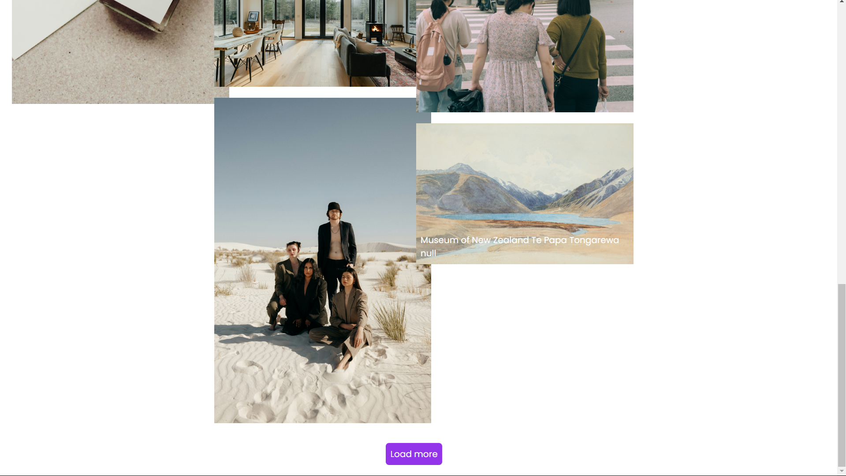

Static Scenario

# Accuracy: The application reliably organizes and displays images, ensuring that users' collections are presented accurately and as intended, regardless of the number or format of the images.User-Friendliness: The interface is intuitive and user-friendly, allowing users to upload, organize, and view images effortlessly. Navigation within the gallery is smooth, and users can easily find and interact with their images.Robustness: Extensive testing has validated the functionality of the image gallery, ensuring that it handles various scenarios, such as different image formats, sizes, and aspect ratios, effectively. The application maintains its performance and accuracy even under challenging conditions.Performance: The image gallery performs efficiently, delivering a seamless browsing experience for users, regardless of the number of images in their collection. Images load quickly, and interactions within the gallery are responsive and smooth.Accessibility: Accessibility features, such as alternative text for images and keyboard navigation options, have been incorporated to ensure that the gallery is accessible to all users, including those with disabilities or using assistive technologies.Scalability: The architecture of the image gallery allows for seamless scalability, accommodating future enhancements and scaling up to support a growing number of images and users without compromising performance or reliability.User Satisfaction: User feedback has been positive, with users expressing appreciation for the ease of use, reliability, and overall experience of using the image gallery. Users find it intuitive to upload and organize their images, and they are satisfied with the performance and accuracy of the application.

# References

## HTML, CSS, and JavaScript Documentation:

## Mozilla Developer Network (MDN) - HTML:

## https://developer.mozilla.org/en-US/docs/Web/HTMLMozilla Developer Network (MDN) - CSS:

## https://developer.mozilla.org/en-US/docs/Web/CSSMozilla Developer Network (MDN) - JavaScript:

## <https://developer.mozilla.org/en->

## Tailwind CSS Documentation:

## Official Documentation: <https://tailwindcss.com/docs>

## Frontend Development Tutorials and Articles:

* + **CSS-Tricks:** https://css-tricks.com/
  + **Smashing Magazine - HTML/CSS:** https://[www.smashingmagazine.com/cat-](http://www.smashingmagazine.com/cat-) egory/css/
  + **JavaScript.info:** https://javascript.info/